DSA LAB 5

1) Implement a circular queue of integers. Include functions insertcq, deletecq and displaycq.

Solution:
#include <stdio.h>
#include <stdlib.h>
#include <string.h>
#define max_size 3
typedef struct{
int *arr;
int front,rear;
}QUE;
void initialize(QUE *cq){
int i;
cq->front = -1;
cq->rear = -1;
cq->arr = malloc(sizeof(int)*max_size);
}
void insertcq(QUE *cq,int x){
if(cq->front == cq->rear && cq->rear == -1){
cq->rear=cq->front=0;
cq->arr[cq->rear]=x;
return;
}
if(cq->front == ((cq->rear)+1)%max_size){
printf("Queue is full\n");
return;
}
cq->rear = ((cq->rear)+1)%max_size;
cq->arr[cq->rear]=x;
}
void deletecq(QUE *cq){
int ele;
if(cq->front == cq->rear){
printf("Queue underflow\n");
return;
}
else{ele = cq->arr[cq->front];
printf("Deleted integer: %d\n", ele);
cq->front=((cq->front)+1)%max_size;
}
}
void display(QUE *cq){
int i;
if(cq->rear == cq->front){
printf("Queue is empty\n");
return;}
else{
for(i=cq->front;i!=cq->rear;i=(i+1)%max_size){
printf("%d ",cq->arr[i]);
}
printf("%d\n", cq->arr[i]);
}
}
int main(){
printf("Yashas Kamath 200905132 Rno 20");
QUE cq;
initialize(&cq);
int ch,x;
do{
printf("\n1.Insert\n2.Delete\n3.Display\n4.Exit\n");
printf("Enter your choice\n");
scanf("%d",&ch);
switch(ch)
{
case 1:
printf("Enter a integer\n");
scanf("%d",&x);
insertcq(&cq,x);
break;
case 2:
deletecq(&cq);
break;
case 3:
display(&cq);
break;
case 4:
exit(5);
}
}while(ch!=4);
return 0;}

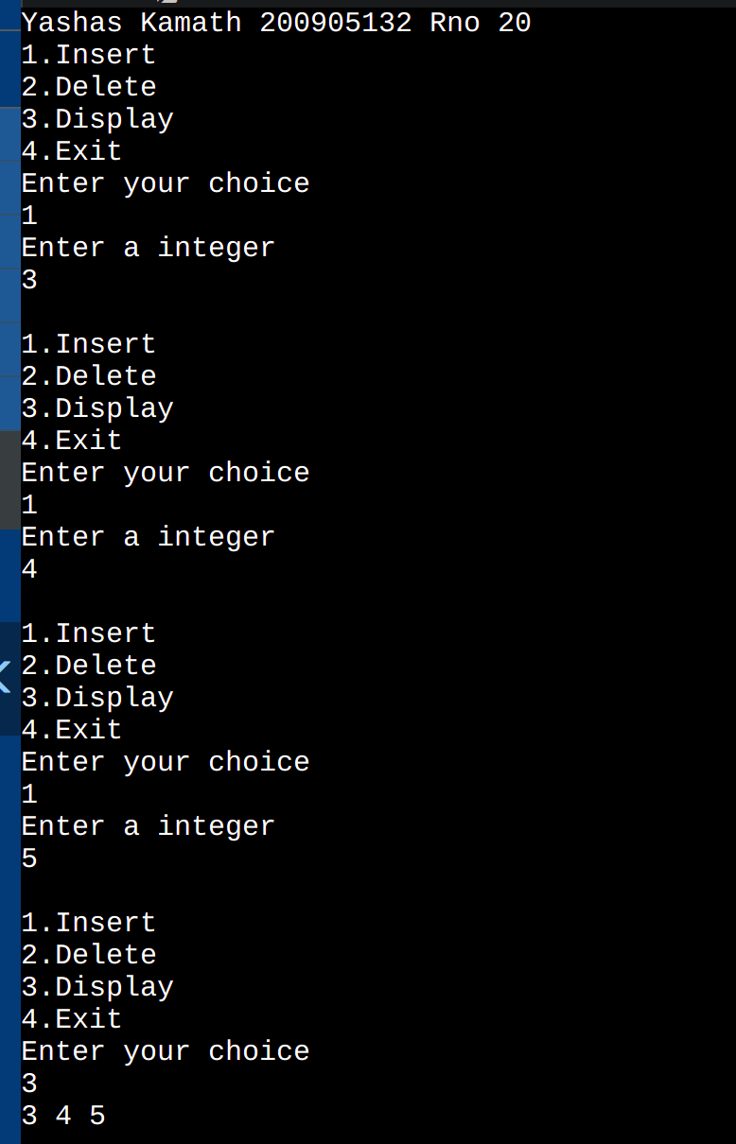

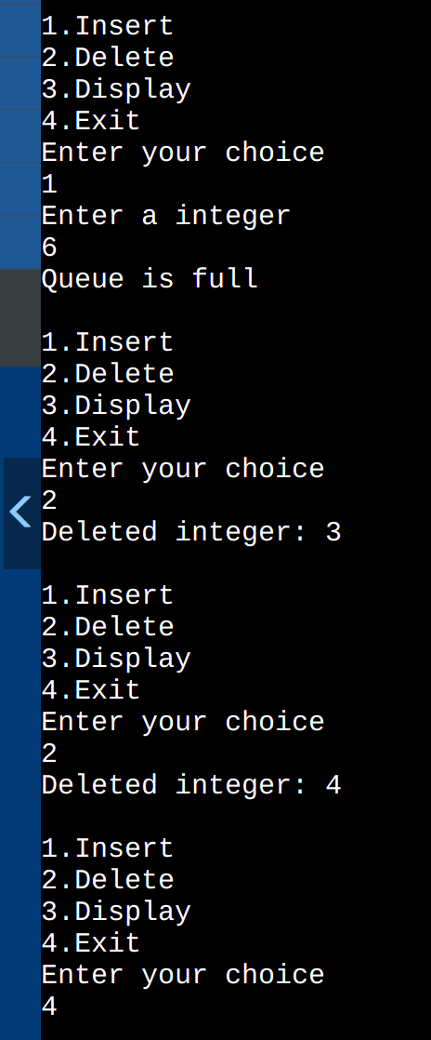

3. Implement a queue with two stacks without transferring the elements of the second stack back to stack one. (use stack1 as an input stack and stack2 as an output stack).

#include <stdio.h>
#include <stdlib.h>
void push1(int);
void push2(int);
int pop1();
int pop2();
void enqueue();
void dequeue();
void display();
void create();
int st1[100], st2[100];
int top1 = -1, top2 = -1;
int count = 0;
void create()
{
top1 = top2 = -1;
}
void push1(int data)
{st1[++top1] = data;
}
int pop1()
{
return(st1[top1--]);
}
void push2(int data)
{
st2[++top2] = data;
}
int pop2()
{
return(st2[top2--]);
}
void enqueue()
{
int data, i;printf("Enter data into queue: ");
scanf("%d", &data);
push1(data);
count++;
}
void dequeue()
{
int i;
for (i = 0;i <= count;i++)
{
push2(pop1());
}
pop2();
count--;
for (i = 0;i <= count;i++)
{
push1(pop2());
}
}
void display()
{
int i;
for (i = 0;i <= top1;i++)
{
printf(" %d ", st1[i]);
}
}

int main()
{
printf("\n Yashas Kamath \t Reg.No.:200905132 \n\n");
int ch = 10;
printf("\n1 - Enqueue into queue");
printf("\n2 - Dequeue from queue");
printf("\n3 - Display queue");
printf("\n4 - Exit");
create();
while (ch != 4){
printf("\nEnter choice: ");
scanf("%d", &ch);
switch (ch)
{
case 1:
enqueue();
break;
case 2:
dequeue();
break;
case 3:
display();
break;
}
}
return 0;
}

